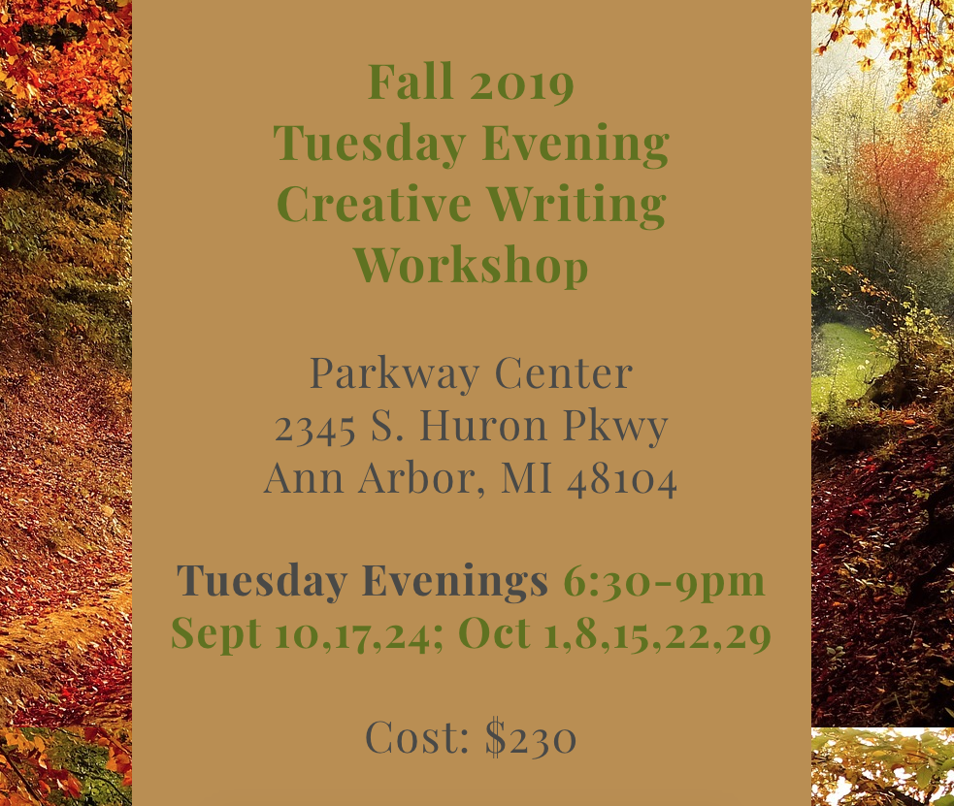
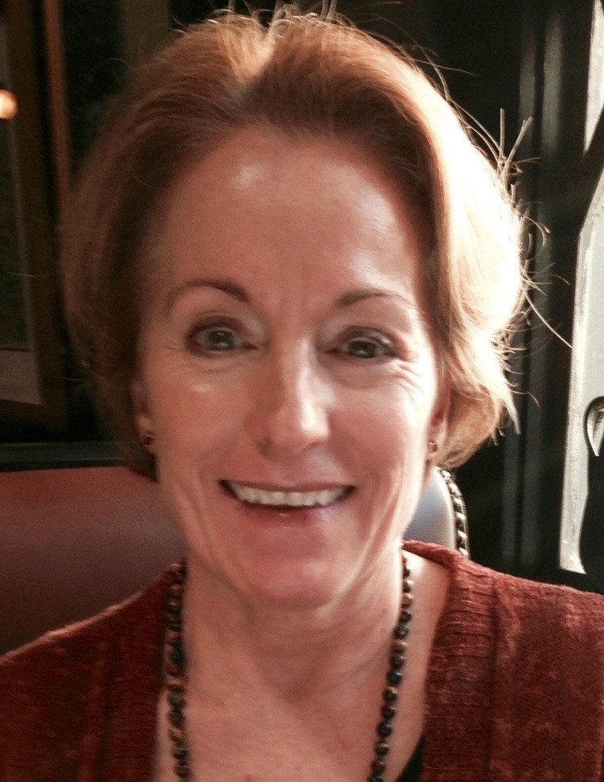
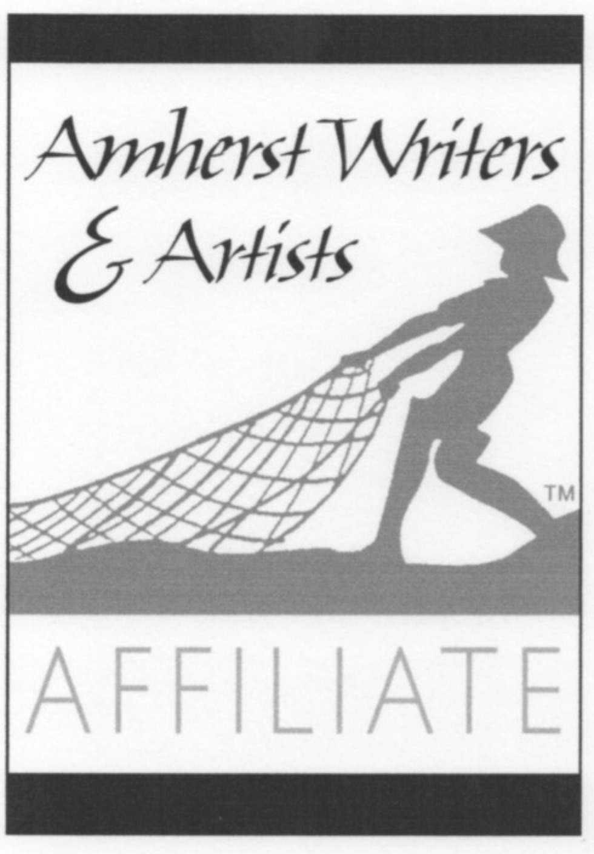
Benefit from the Healing Power of Writing

Beginners & Experienced Writers Welcome!

Leader: Julie Mariouw is a published author, english teacher, certified Amherst Writers & Artists workshop leader

For More Info/To Enroll:
https://www.wellspringwritingworkshops.com/events

